Fault-Tolerant Routing Algorithm for Unidirectional Networks
C.W. Lam and F.C.M.Lau
ISPAN 2002, pp 329-333
Abstract
We present an improved version of a distance-vector protocol for routing in networks with unidirectional links, which has the added capabilities to handle link and node faults as well as addition and deletion of nodes.
- Previous work
- An improved algorithm

The protocol consists of three algorithms, From, To and F-Neighbor.

Each node maintains its own tables, a From table, a To table and a F-neighbor table, as well as From tables of all its f-neighbors.
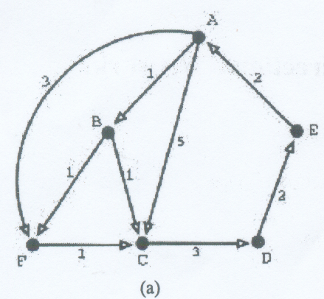

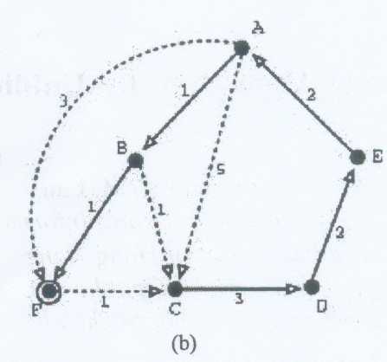

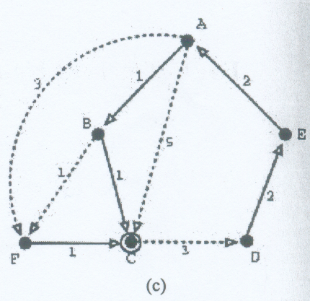
Created by : Rei-Sing Cheng
Date : Aug. 6, 2002

